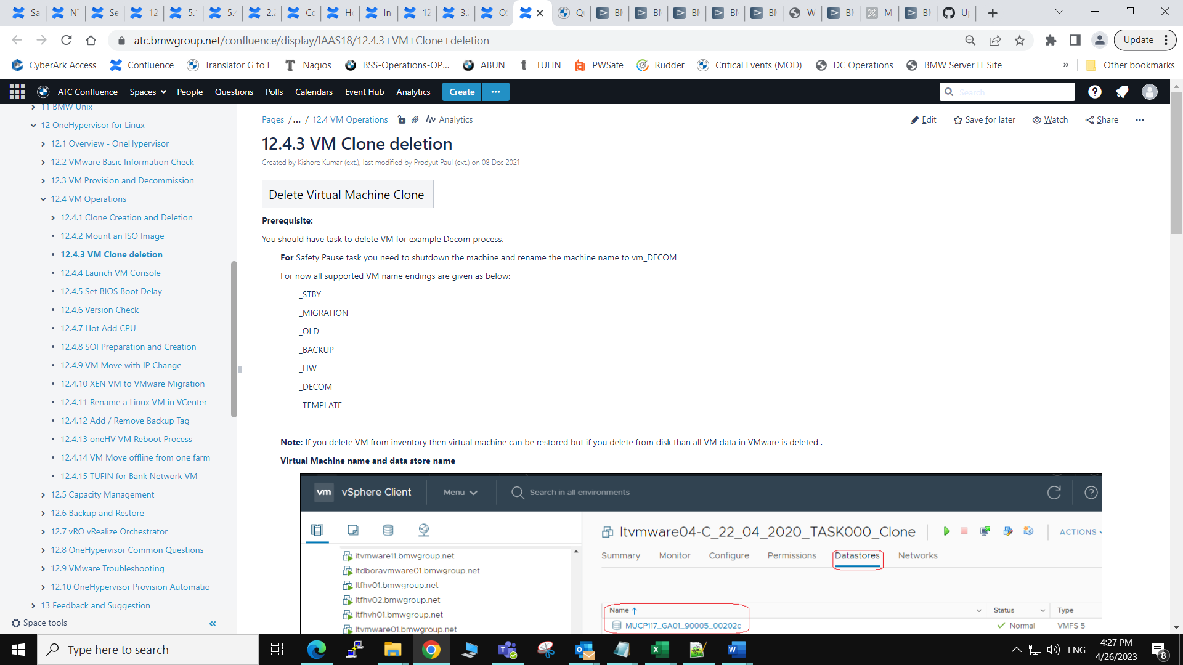

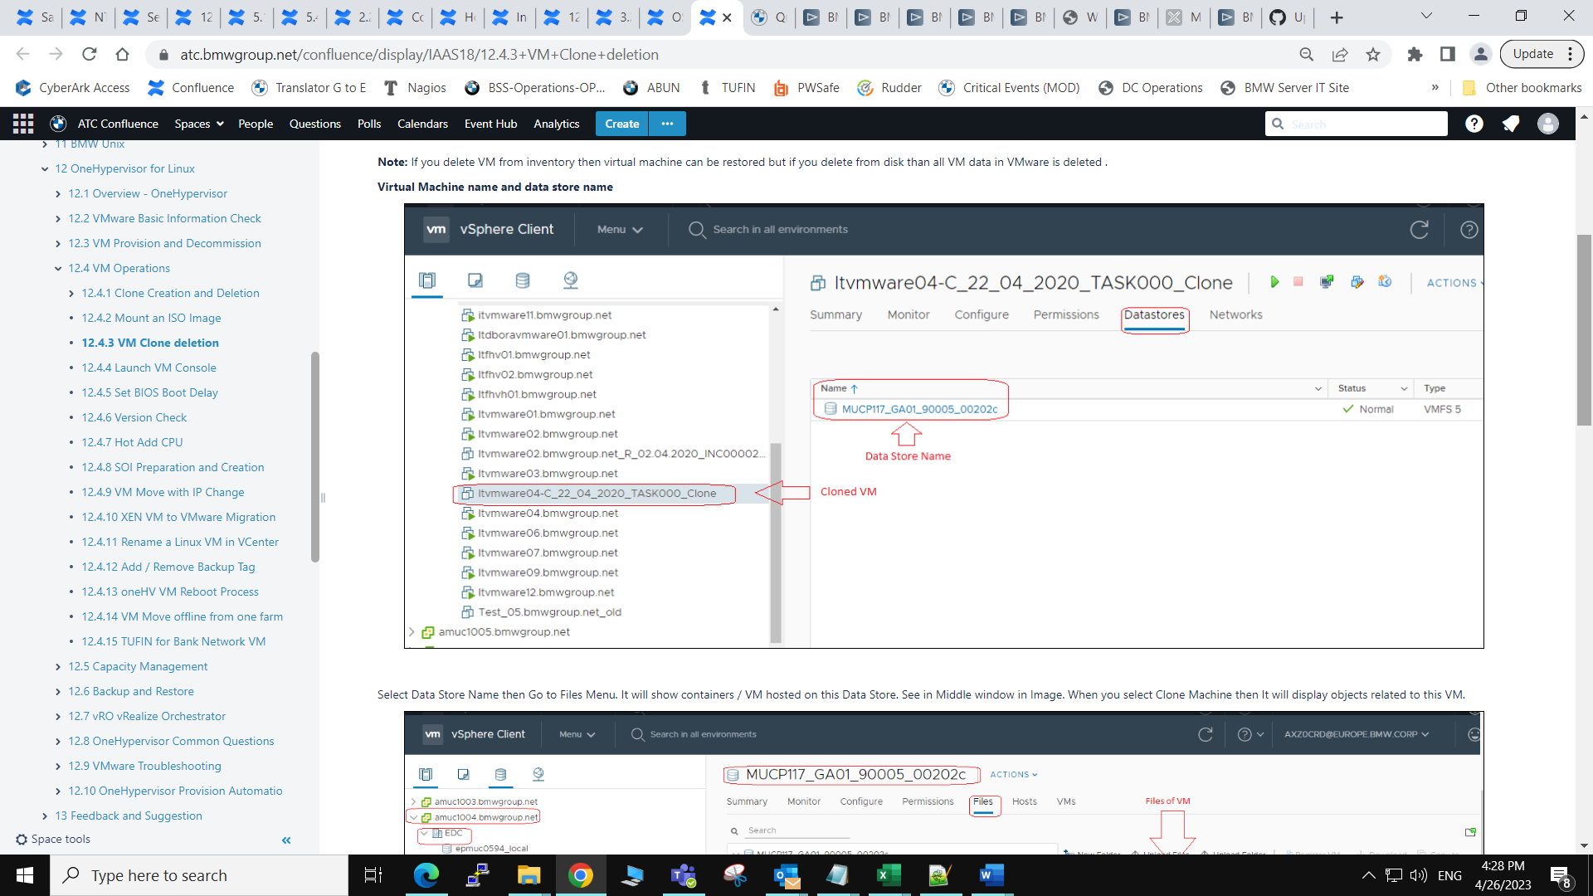

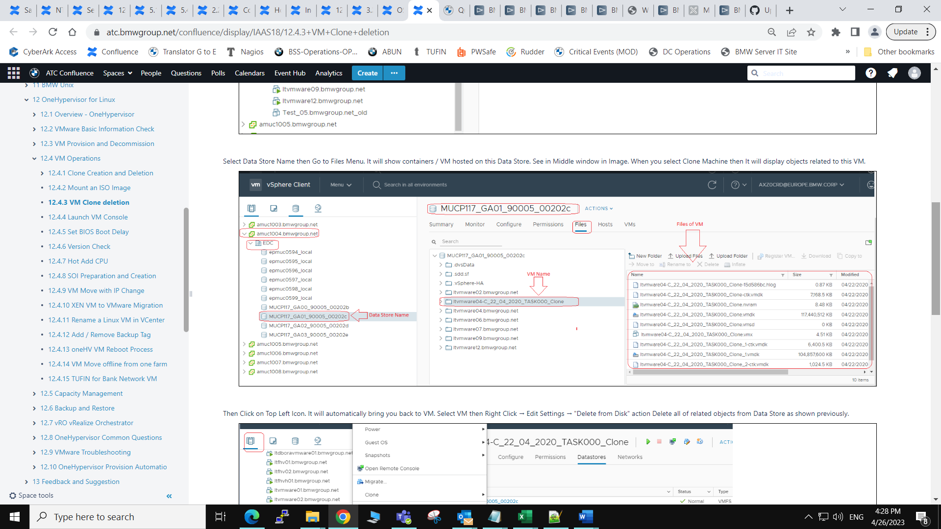

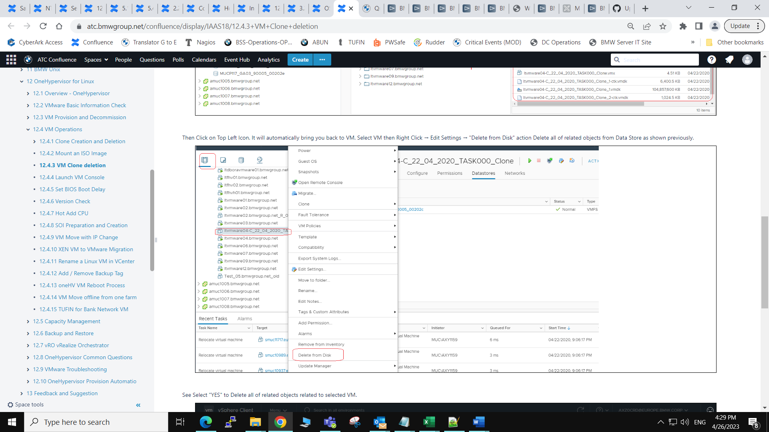

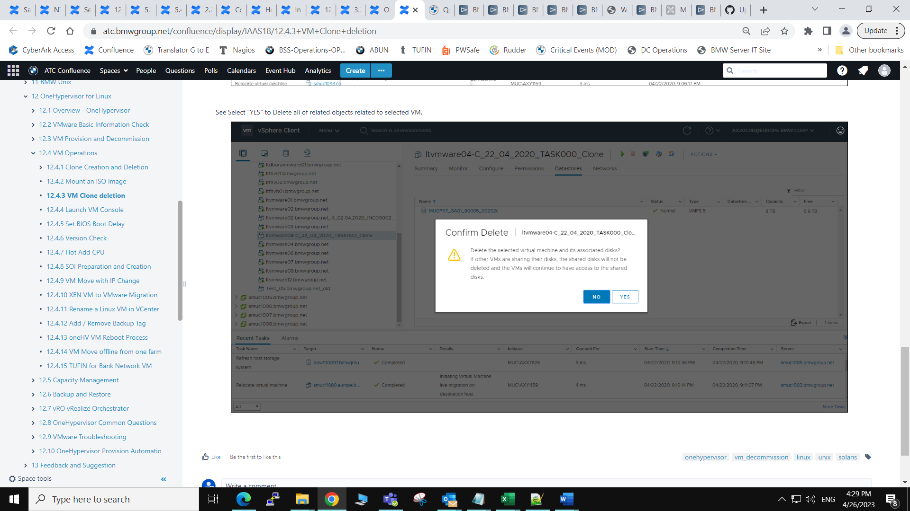

* Created by [Kishore Kumar (ext.)](https://atc.bmwgroup.net/confluence/display/~qxz0crd), last modified on [30 Sep 2021](https://atc.bmwgroup.net/confluence/pages/diffpagesbyversion.action?pageId=1465559287&selectedPageVersions=8&selectedPageVersions=9)

| VM Migration Process (XEN to VMware) |
| --- |

Process for Virtual Server

**1.** OS Install - Unix team - Done

**2.** Adding server IDAS role to AD group - BMW application responsible/server owner or middleware team need to raise [RoleRequest_linux](https://atc.bmwgroup.net/confluence/display/LINUX/RoleRequest_linux) (new role) or [RoleModifyRequest_linux](https://atc.bmwgroup.net/confluence/display/LINUX/RoleModifyRequest_linux) (existing role). Unix team should provide this information incl. links to customer

**3.** Users -

a) Local (standard/qq) - app team need to open a task [server-unix-std:global|06|001s-user-mgmt-(NSTC)](https://atc.bmwgroup.net/confluence/pages/viewpage.action?pageId=668330528) for use to create local users if the were not already requested in ITSSP when the servers was ordered.

b) AD user -  UNIX team will validate the users (if the user is not belongs to allowed AD group then app team need to contact role owner/approver, which can be looked up in IDAS by the customer)

**4.** Sudo Rule-

a) default rules will be present

b) if there are some for a certain module- additional rules - app team need to open a new request via Task template [server-unix-std:global|06|002-sudo-mgmt-(NSTC)](https://atc.bmwgroup.net/confluence/pages/viewpage.action?pageId=668330532)

**5.** NFS file system

a) Share owner needs to export the shares to server via <https://istore.bmwgroup.net/>

b) Unix team will mount the exported shares when requested via task  [server-unix-std:global|06|035s-nfs-mount-filesystem AP](https://atc.bmwgroup.net/confluence/display/IAAS18/NTT+Task+Template+List+-+Linux#NTTTaskTemplateListLinux-unix-std%3Aglobal%7C06%7C035s-nfs-mount-filesystem%20AP)

**6.** SAN file system:

a) App team need to open a task [server-unix-std global |06| 030s-san-change-filesystem-(NSTC)](https://atc.bmwgroup.net/confluence/pages/viewpage.action?pageId=668330519) to Unix team for SAN file system if not already requested in ITSSP

b) Unix team will create a required file system

**7.** App team need to install the application and configure

**8.** Data backup:

OS data - Unix team will do

App Dada- App team need to restore

Other Activities:

**1.** Move of IP alias: Unix team will do on task request

**2.** Backup config- UNIX team will do

OS backup request by default its requested

APP backup app team need to request (open a backup request)

**3.** DB update: CMDB - UNIX team will do with respect to OS